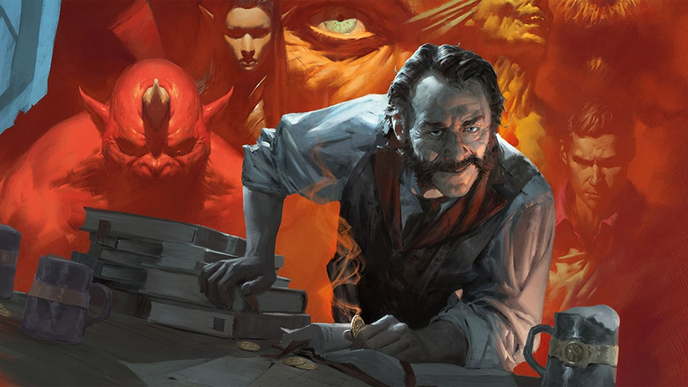

‘Announcing TaylorWorld’s New Dungeons and Dragons Game.’
—
We are interested in most Table Top Role-Playing Games (RPGs), such as Dungeons and Dragons, and are looking for players to join us to begin the first game of an Advanced Dungeons and Dragons D20 based, medieval and fantasy RPG campaign based in ‘The World of Greyhawk’ world setting. The game is open to both sexes of all ages, however as the game will tackle adult themes, provided you can watch an 18 rated film it’s all good with us!

Games will hopefully be played on Saturday afternoons at the ‘Bailiffs Tap’ next to the ‘Three Pigeons’ so register your interest by emailing us.

Our website is https://odoo.taylorworld.one
Our contact emails are ptaylor@taylorworld.one. Or yossarian76543@yahoo.co.uk for details.

If you see this leaﬂet and you’re interested in joining us for a game, email us, or show your interest in the Bailiﬀs Tap in Banbury, Oxfordshire and ask for Dan, or leave a message on our Facebook page https://www.facebook.com/brobostigon/, ‘Taylorworld Tabletop RPG’s’

We will be hosting games and information sessions at the Bailiﬀs Tap in Banbury, Oxfordshire, which we will publish on our Facebook Page, where you can get reacquainted with the table-top RPGs you love and remember, as well as for people newly interested in table-top RPGs, to start their learning experience with us.

Copyright 2019, Philip Martin Taylor, TaylorWorld.
Open Game License v 1.0a Copyright 2000, Wizards of the Coast, LLC.
System Reference Document 5.1 Copyright 2016, Wizards of the Coast, based on original material by E. Gary Gygax and Dave Arneson.
Dungeons and Dragons and World of Greyhawk are Registered Trademarks of Wizards of the Coast LLC.

